You need the MetaMask which is a Ethereum wallet that you can install inside your Chrome browser,.

Signing

1. Create the message hash to sign

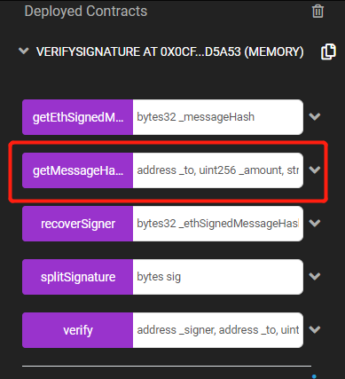

Put the address(you can copy your account), then for the number, message that you will encrypt, nouns or pass.

Example: 0xc1B86DD0859adF76e09F0599E407376015bB7231,123,"UNICAM",1

After put the data, call the function, we will get the hash that we are going to be signing and to sign the hash we need to allow Remix to connect to MetaMask.

Open the JavaScript console, input "ethereum.enable()". After put the password and connect, you have access to MetaMask inside the browser console.

1. Sign the hash

Put the "hash = "from last step you get the hash""

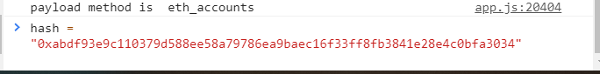

Then we need to call "web.personal.sign(hash, web.eth.defaultAccount, console.log)"

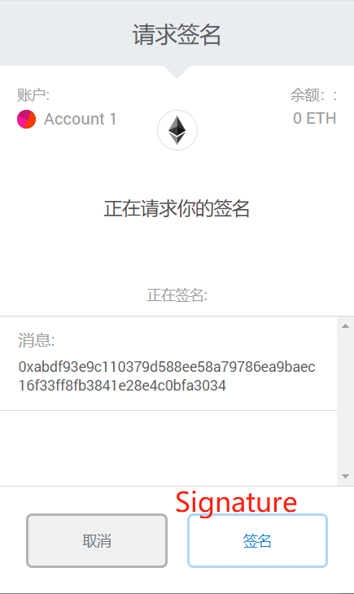

Click the "Signature"

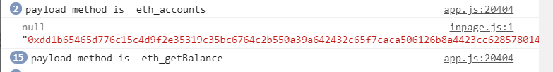

That is the signature we get! The signature will be different for different accounts

Verify

1. We need the address of the signer, put "web3.eth.defaultAccount" on console, we will get it

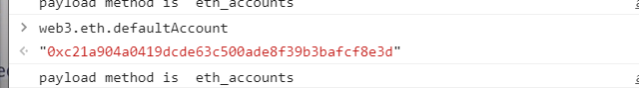

1. Put data in "Verify" function

"Address, the message we used to sign, signature itself"

Example: 0xc21a904a0419dcde63c500ade8f39b3bafcf8e3d, 0xc1B86DD0859adF76e09F0599E407376015bB7231,123,"UNICAM",1, 0xdd1b65465d776c15c4d9f2e35319c35bc6764c2b550a39a642432c65f7caca506126b8a4423cc62857801465e52d0be3b8cc4659e8ea3eab9c80e636a2d8c3211c

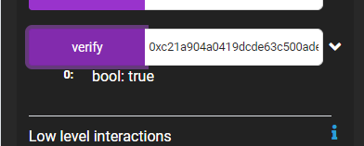

If you modify every character of this data they will print "false"

